Using Respondus LockDown & Monitor
Respondus LockDown Browser and Monitor give you tools to ensure academic integrity on your Canvas quizzes by controlling what the learner can do while testing.

Enable LockDown Browser & Monitor
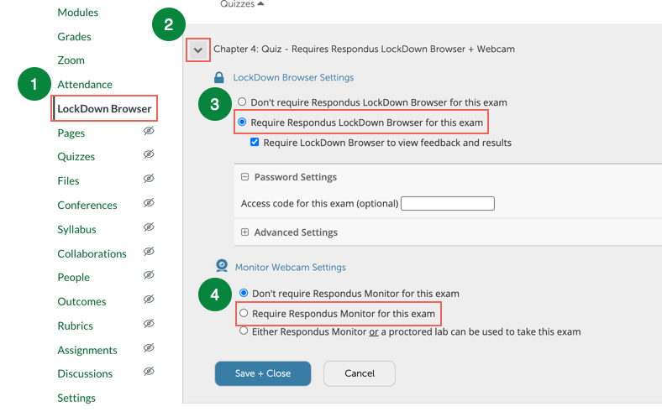
Visit Settings/Navigation to add LockDown Browser to your Course Navigation links. Then follow the four steps below. You must create a quiz before you can change LockDown Browser settings.
  - Step 1: Click on the LockDown Browser link to open the Respondus Dashboard.
  - Step 2: Click the chevron next to the name of the quiz and choose Settings from the dropdown.
  - Step 3: Select the radio button next to “Require Respondus LockDown Browser for this exam.” to enable LockDown Browser only.
  - Step 4: Select the radio button in the last section to enable Respondus Monitor if you wish to record the student’s webcam during the quiz. Monitor cannot be enabled unless LockDown Browser is enabled first.

Review Respondus Monitor Videos
If you have enabled Respondus Monitor, you will be able to access student recordings and make judgments on flagged or questionable conduct
  - Click the LockDown Browser link in your Course Navigation.
  - Select “Class Results” located to the left of the quiz title.
  - Click [+] for information on a student.
  - Click a thumbnail to review video taken at timed intervals during the exam. Suspicious activity will automatically be flagged for review.

Get More Help with Respondus
  - Review this video for more information on using Respondus LockDown Browser and Monitor.

